Assignment – Storing Scorecards

Shaun Pritchard

Rasmussen College

QMB4400

Tina Harclerode

May 2, 2021

Tina,

These where the instructions for generating SQL and output to the tables. If I am missing something can you please be more specific because I was more than certain this was what you explained for us to do in the adsignment

* Create a SQLite table with following columns as described in the csv file and name it as Cohorts table
* Insert data into the SQLite table
* Store the data into the Pandas DataFrame
* Print the result using read_sql statement.

I have included all the necessary requirements and files for this project also I have provided a link to the cloud Google colab working script file.

<https://colab.research.google.com/drive/1tBo42QxqMqCDxrOWEtcFSK-9BbDRzBJW?usp=sharing>

**Assignment output:**

**I imported the data set and my initial libraries. I also validated the headers and content of the csv dataset.**

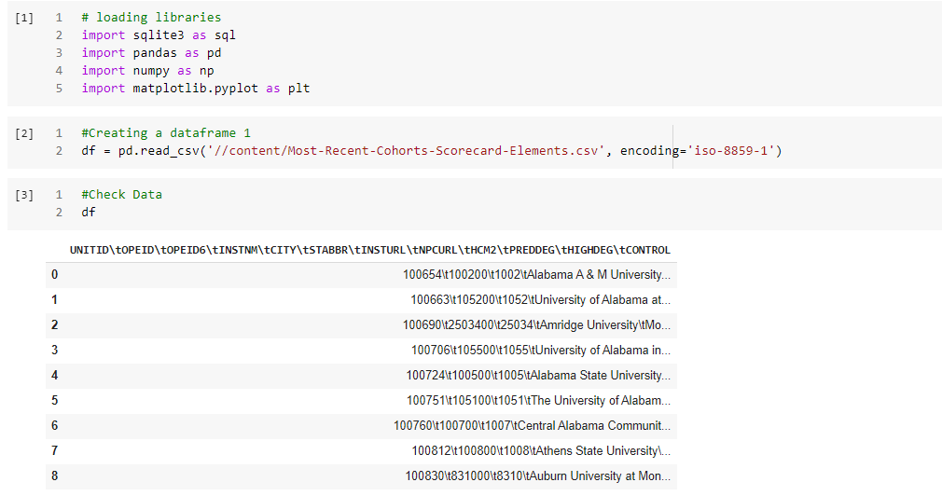

**Here is where I completed the assignment:**

* Create a SQLite table with following columns as described in the csv file and name it as Cohorts table cohorts. db was created and the csv file was appended to the database in a table
* Insert data into the SQLite table
* Store the data into the Pandas DataFrame – I then sent the data to a dataframe using **pd.read_sql**

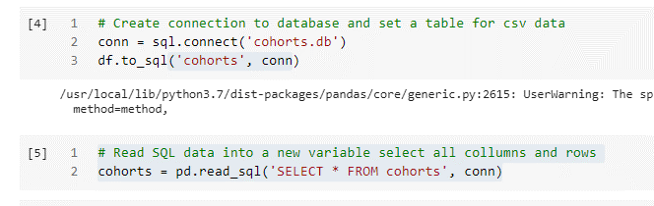

**I then printed the output of the csv stored in the SQLite database that was restored in a new variable dataframe from above.**

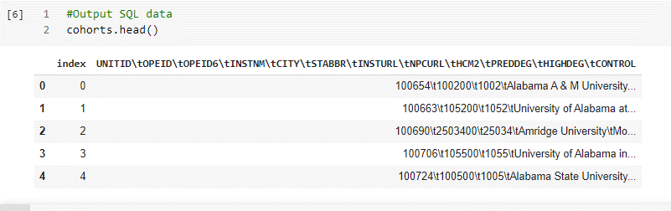

**I then added some extra features not allocated in the instruction such as printing the descriptive statistics for the table data and outputting the results to a JSON file?**

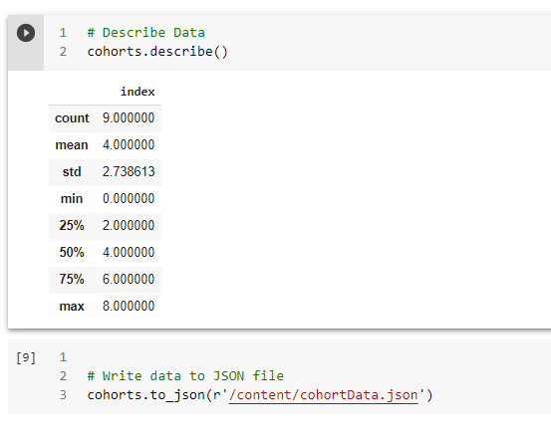

**I attached all output files and datasets in this email can you please tell me what I did wrong?**